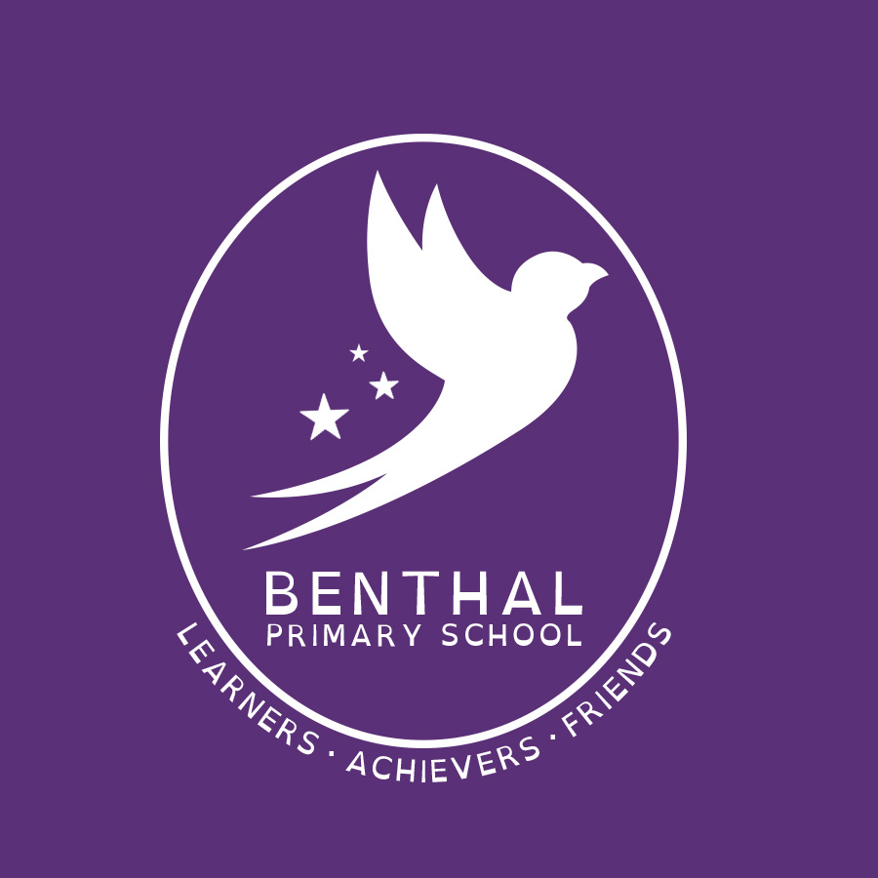

Safeguarding Policy: COVID-19 addendum
Jan 2021

Approved by: | Louise Drew | Date: Jan 2021
Last reviewed on: Sept 2021
Next review due by: | will be set in response to Government guidance in Feb 2021
Contents
Important contacts 3
1. Scope and definitions 4
2. Core safeguarding principles 4
3. Reporting concerns 4
4. DSL (and deputy) arrangements 4
5. Working with other agencies 5
6. Monitoring attendance 5
7. Peer-on-peer abuse 5
8. Concerns about a staff member or volunteer 6
9. Support for children who aren’t ‘vulnerable’ but where we have concerns 6
10. Safeguarding for children not attending school 6
11. Online safety 6
12. Mental health 8
13. Staff recruitment, training and induction 8
14. Children attending other settings 9
15. Monitoring arrangements 9
16. Links with other policies 9

Important contacts

Role/organisation | Name | Contact details
Designated safeguarding lead (DSL) and Assistant Head teacher for Inclusion and Safeguarding | Jill Joseph | 0208 985 9310  jjoseph@benthal.hackney.sch.uk
Local authority designated officer (LADO) and DSL | Louise Drew | 0208 985 9310  PA@benthal.hackney.sch.uk
Deputy DSL and Assistant Head Teacher for Early Years | Christiane Nkaka | 0208 985 9310  cnkaka@benthal.hackney.sch.uk
Deputy DSL and Deputy Head Teacher | Tracy Williams | 0208 985 9310  twilliams@benthal.hackney.sch.uk
Chair of governors | Stella Sandford | office@benthal.hackney.sch.uk
Channel helpline |  | 020 7340 7264

1. Scope and definitions
This addendum applies during the period of school closure due to COVID-19, and reflects updated advice from the government and our 3 local safeguarding partners:
- Hackney Local Authority
- Hackney Children’s Services
- Metropolitan Police –Stoke Newington, Hackney
It sets out changes to our normal child protection policy in light of the Department for Education’s guidance Coronavirus: safeguarding in schools, colleges and other providers, and should be read in conjunction with that policy.
Unless covered here, our normal child protection policy continues to apply.
The Department for Education’s (DfE’s) definition of ‘vulnerable children’ includes those who:
- Have a social worker, including children:
- With a child protection or Child In Need plan
- Assessed as being in need
- Looked after or Previously Looked after by the local authority
- Have an Education, Health and Care (EHC) plan

2. Core safeguarding principles
We will still have regard to the statutory safeguarding guidance, Keeping Children Safe in Education.
Although we are operating in a different way to normal, we are still following these important safeguarding principles:
- The best interests of children must come first
- If anyone has a safeguarding concern about any child, they should continue to act on it immediately
- A designated safeguarding lead (DSL) or deputy should be available at all times (see section 4 for details of our arrangements)
- It is crucial that only essential services have access to the school building and the children
- Children should continue to be protected when they are online

3. Reporting concerns
All staff and volunteers must continue to act on any concerns they have about a child immediately. It is still vitally important to do this.
In the event that you are unable to access the usual ‘Sharing concerns form’ email your concerns to any member of the Senior Leadership Team (SLT) details in the contact list on Page 4.
As a reminder, all staff should continue to work with and support children’s social workers, where they have one, to help protect vulnerable children.

4. DSL (and deputy) arrangements
We aim to have a trained DSL or deputy DSL on site at all times. Details of important contacts are listed in the ‘Important contacts’ section at the start of this addendum on Page 3.
We will keep all school staff and volunteers informed by email/SMS as to who will be the DSL (or deputy) on any given day, and how to contact them.
We will ensure that DSLs (and deputies), wherever their location, know who the most vulnerable children in our school are. On occasions where there is no DSL or deputy on site, a senior leader will take responsibility for co-ordinating safeguarding. This will be Anna Jassim, Business manager. You can contact her by email: ajassim@benthal.hackney.sch.uk or phone:0208 935 9310
The senior leaders will be responsible for liaising with the off-site DSL (or deputy) to make sure they (the senior leader) can:
- Identify the most vulnerable children in school
- Update and manage access to child protection files, where necessary
- Liaise with children’s social workers where they need access to children in need and/or to carry out statutory assessments
- Make a referral to Children’s services or Police.

5. Working with other agencies
We will continue to work with children’s social care, and with virtual school heads for looked-after and previously looked-after children.
We will continue to update this addendum where necessary, to reflect any updated guidance from:
- The Government
- Our 3 local safeguarding partners
- The local authority about children with education, health and care (EHC) plans, the local authority designated officer and children’s social care, reporting mechanisms, referral thresholds and children in need

6. Monitoring attendance
As most children will not be attending school during this period of school closure, we will not be completing our usual attendance registers or following our usual procedures to follow up on non-attendance.
The exception to this is where any child we expect to attend school during the closure doesn’t attend, or stops attending. In these cases we will
- Follow up on their absence with their parents or carers, by making a phone call to the parent/carers on every day that the child does not attend
- Notify their social worker, where they have one
- Seek advice from Children’s services FAST on 0208 356 5500 (out of hours 0208 356 2710)
We are using the Department for Education’s daily online attendance form to keep an accurate record of who is attending school.
We will be monitoring pupil’s attendance to scheduled online learning sessions. Failure to attend online lessons without good cause will result in further investigation by Benthal school, Hackney Education or Hackney Children’s services.
We will make arrangements with parents and carers to make sure we have up-to-date emergency contact details and additional contact details where possible. We will do this by making
- Termly requests by letter for contact details to be updated.
- Half termly reminders in the school newsletter requesting an update of contact details
- Personal text/email messages to individual families. For example, following on from information provided by one or any of our Safeguarding partners (Page 4)

7. Peer-on-peer abuse
We will continue to follow the principles set out in part 5 of Keeping Children Safe in Education when managing reports and supporting victims of peer-on-peer abuse.
Staff should continue to act on any concerns they have immediately.
During periods of school closure, we will continue to support victims of peer-on-peer abuse and their families by making
- Direct contact by phone (at agreed times and regularity)
- Liaising with our Safeguarding partners.
- Making timely referrals to Support agencies

8. Concerns about a staff member or volunteer
We will continue to follow the principles set out in part 4 of Keeping Children Safe in Education.
Staff should continue to act on any concerns they have immediately.
We will follow our Disciplinary & Conduct and Safeguarding Policies and contact Hackney Learning Trust HR department for any additional support if an investigation is required into staff conduct.
We will continue to refer adults who have harmed or pose a risk of harm to a child or vulnerable adult to the Disclosure and Barring Service (DBS).
We will continue to refer potential cases of teacher misconduct to the Teaching Regulation Agency. We will do this using the email address Misconduct.Teacher@education.gov.uk for the duration of the COVID-19 period, in line with government guidance.

9. Support for children who aren’t classed as ‘vulnerable’ but where we have concerns
We have the option to offer places in school to children who don’t meet the Department for Education’s definition of ‘vulnerable’, but who we have safeguarding concerns about. We will work with parents/carers to do this.
These could be children who:
- have previously had a social worker
- have not met the threshold for a referral but where staff have raised concerns.
- Have previously been ‘Looked after’ by Local authority
- Are receiving Free school meals (FSM) or Pupil Premium Grant (PPG)

If these children will not be attending school, we will put a contact plan in place, as explained in section 10.1 below.

10. Safeguarding for children not attending school
10.1 Contact plans
We have contact plans for children with a social worker and children who we have safeguarding concerns about, for circumstances where:
- They won’t be attending school (for example where the school, parent/carer and social worker, if relevant, have decided together that this wouldn’t be in the child’s best interests); or
- They would usually attend but have to self-isolate
These plans set out:
- Who the plan is for
- How contact will be recorded
- Which staff member(s) will make contact
- How they will make contact
- Any resources or benefits the school can provide
We have agreed these plans with children’s social care where relevant and will review them weekly/monthly or termly as relevant to each individual case. (see Appendix 1)

If we can’t make contact, we will contact our Safeguarding partners (see page 4) for advice or follow up action.
We have a protocol to guide staff who hold responsibility for contacting children. This guide is in the form of a flowchart giving options for sequence of events and recommendations for actions to be taken where there are concerns about a child’s wellbeing when they are not in school and not attending online learning sessions (see Appendix 2)
10.2 Safeguarding all children
Staff and volunteers are aware that this difficult time potentially puts all children at greater risk.
Staff and volunteers will continue to be alert to any signs of abuse, or effects on pupils’ mental health that are also safeguarding concerns, and act on concerns immediately. Particularly as children will be spending more time online (see section 11 below). We will ensure that:
- All staff receive safeguarding updates and a copy of this addendum
- We monitor attendance of vulnerable pupils daily to ensure non-attendance to school or online learning is investigated.
- DSL’s will monitor Encompass police information for details of children who have been victims of or exposed to domestic violence during lockdown/school closure.
- Hand over requests will be made to our partners for children who are transferring to a new school out of borough
- All pupils will be given refresher sessions about using the NSPCC Child line and personal well-being. (PANTs, PHSE)
- All children will be issued with a ‘Help in my pocket’ card giving information about getting help for themselves
- DSL’s attend all online meetings for children with a ‘Child in need’ or ‘Child protection’ Plan
- Our professional ‘Team around the School’ (Senco, Specialist teacher and Speech and Language Specialist, Mental Health Specialist) will hold weekly reviews regarding supporting pupils at both home and school.

11. Online safety
11.1 In school
We will continue to have appropriate filtering and monitoring systems in place in school. We will use our current IT technical support team as and when it is required.
If IT staff are unavailable, our contingency plan will be to contact the IT technical team at Hackney Learning Trust.
11.2 Outside school
Where staff are interacting with children online, they will follow guidance outlined in our existing Staff handbook, Code of conduct, Remote Learning policy and E-Safety policy
Staff will also refer to the addendum to Benthal E-safety Policy – School procedures for Online use during school closure, Staff Protocols document which includes an EYFS specific version.(see Appendix 3)
Staff will continue to be alert to signs that a child may be at risk of harm online, and act on any concerns immediately, following our reporting procedures as set out in section 3 of this addendum.
We will make sure children know how to report any concerns they have, who they can report to and signpost them to other sources of support if required such as Kooth, Young Hackney, NSPCC.
11.3 Working with parents and carers
We will make sure parents and carers:
- Are aware of the potential risks to children online and the importance of staying safe online
- Know what our school is asking children to do online, including what sites they will be using and who they will be interacting with from our school
- Are aware that they should only use reputable online companies or tutors if they wish to supplement the remote teaching and resources our school provides
- Know where else they can go for support to keep their children safe online (NSPCC, ChildLine)

Parents will refer to the addendum to Benthal’s E-Safety policy – Parent and Carer’s Guidance for using class emails. (See Appendix 4)

12. Mental health
We will continue to offer support for promoting the mental health of all pupils. We will do this by:
- Maintaining contact protocols for our most vulnerable pupils.
- Employing strategies to build resilience such as Zones of Regulation, Trauma-informed practice and PHSE.

We will also signpost all pupils, parents and staff to other resources to support good mental health at this time.
When setting expectations for pupils learning remotely and not attending school, teachers will bear in mind the potential impact of the current situation on both children’s and adults’ mental health.

13. Staff recruitment, training and induction
13.1 Recruiting new staff and volunteers
We continue to recognise the importance of robust safer recruitment procedures, so that adults and volunteers who work in our school are safe to work with children.
We will continue to follow our safer recruitment procedures and part 3 of Keeping Children Safe in Education.
In urgent cases, when validating proof of identity documents to apply for a DBS check, we will initially accept verification of scanned documents via online video link, rather than being in physical possession of the original documents. This approach is in line with revised guidance from the DBS.
New staff must still present the original documents when they first attend work at our school.
We will continue to do our usual checks on new volunteers and do risk assessments to decide whether volunteers who aren’t in regulated activity should have an enhanced DBS check, in accordance with paragraphs 167-172 of Keeping Children Safe in Education.
13.2 Safeguarding induction and training
We will make sure staff and volunteers are aware of changes to our procedures and local arrangements.
New staff and volunteers will continue to receive:
- A safeguarding induction
- A copy of our children protection policy (and this addendum)
- Keeping Children Safe in Education part 1
We will decide on a case-by-case basis what level of safeguarding induction staff ‘on loan’ need. In most cases, this will be:
- A copy of our child protection policy and this addendum
- Confirmation of local processes
- Confirmation of DSL arrangements
13.3 Keeping records of who’s on site
We will keep a record of which staff and volunteers are on site each day, and that appropriate checks have been carried out for them.
We will continue to keep our single central record up to date.
We will use the single central record to log:
- Everyone working or volunteering in our school each day.
- Details of any risk assessments carried out on staff and volunteers on loan from elsewhere.

14. Children attending other settings
Where children are temporarily required to attend another setting, we will make sure the receiving school is provided with any relevant welfare and child protection information.
Wherever possible, Jill Joseph, our DSL (or deputy) /Special educational needs co-ordinator (SENDCO) will share, as applicable:
- The reason(s) why the child is considered vulnerable and any arrangements in place to support them
- The child’s EHC plan (EHCP), Child in Need plan (CIN), Child Protection plan (CP) or Personal Education plan (PEP)
- Details of the child’s social worker
- Details of the virtual school head
Where the DSL/ SENCO or deputies can’t share this information, the senior leader(s) identified in section 4 will do this.
We will share this information before the child arrives as far as is possible, and otherwise as soon as possible afterwards.

15. Monitoring arrangements
This policy will be reviewed as guidance from the Government, 3 local safeguarding partners, the LA or DfE is updated, and as a minimum of 3-4 weeks by the Senior Leadership Team (SLT). At every review it will be approved by the Chair of the Board and the Safeguarding Link Governor.

16. Links with other policies
This policy links to the following policies and procedures:
- Safeguarding/Child protection policy
- Wellbeing Policy
- Staff Handbook and Code of Conduct
- Remote Learning Policy/ Home learning Guidance to parents
- IT acceptable use policy
- Health and safety policy
- Online E-safety policy
- Whistleblowing policy

Appendix 1


School closure Contact Plan for ___________ Date:

Dear Parent,

This plan has been put in place to help support _________ when they are not at school.
If your child has been offered a place at school but will not be attending, you are required to inform the school that your child will be absent, giving a reason for example:
They won’t be attending school because the school, parent/carer and social worker, if relevant, have decided together that this wouldn’t be in the child’s best interests; or
They would usually attend but have to self-isolate

This plan describes:
- How often Benthal School will make contact with your child – this will be discussed and agreed with the Safeguarding team/SLT and our partners ie Health, Children’s services, Police.-
- How contact will be recorded - Using a contact record form to be completed during or immediately after a call (see example below)
- Who will have responsibility for making contact – this may be any member of staff who is working with your child
- How contact will be made - By phone to main carer details held by school. Missed /unanswered calls will be followed up by an SMS/text message
- Information about school resources that may help support you and your family
- Referrals to other services or partners - How school will work with other services to support your child/family

Contact plan for
Staff member(s) who will make contact
We will contact you by
resources or benefits the school can provide
Other services who are involved

Appendix 2
Protocol for making contact with pupils during school closure
Phone call to main carer
Is pupil available to talk?
Call answered?
Carer calls back
YES
YES
NO
Refer to DSL/SLT
Refer to pupil contact plan
Call answered?
YES
Send a text
For
Call again in
30 minutes

0 mins
NO

NO

Follow question prompts below
Are you satisfied with the reason?
With

Arrange a time for a follow –up call, if child still not available
Concerns raised by child or adults response

Refer to FAST children’s service on 0208 356 5500

Questions to ask the child.
How are you? Is everyone well?
How are you getting on with the home learning pack? Are you reading every day?
Are you getting enough fruit? (an opener to check if they are getting adequate food)
Have you been getting enough rest?
Examples of cause for concerns:
• Parent seems agitated, angry or uncooperative.
• Parent is heard coaching child on what to say.
• Child makes a disclosure.
• Child is not available at the agreed call back time.
Concerns, no matter how small, must be referred to a DSL using a sharing concerns form immediately.


APPENDIX 3

School Protocols for online use during school closure
During school closure and to ensure the safety of you as a member of staff all online outputs from the school need to strictly adhere to the Safeguarding Policy, E-Safety Policy and the Staff Handbook particularly the Staff Code of Conduct.
Remote Learning:
We are using Marvellous Me for Yr2-6 and Tapestry for EYFS and Year 1. The purpose of the twice daily contact is to set the children’s work, to maintain contact and to let them know we’re keeping them in mind.
Tapestry
Please see additional documents for staff protocols and parent/carers guidance.
Class based Email for children in Y 2-6 Guidance for Staff:
We have set up an email address for each class for example rowan@benthal.hackney.sch.uk for teachers to contact children and families. This will be useful when sending new timetables and tasks for week 4.
- Anna will send you details and the password of how to access your class based email. The password is NOT to be changed.
- This email is NOT your school/workplace email and you should NOT send messages that are workplace related using this email- it is to email families only.
- Staff are to communicate with children using their parents’ email addresses only. Anna will give you these for your class. The school office will chase up any families that we do not have an email address for and let you know in due course.
- If you receive an email from an address that is not on the list, please call the school office to check and they will follow up with a phone call to verify the email. Do NOT respond in any way before you receive confirmation from the school office to do so. If the office inform you that it is unknown, then please delete.
- Do USE email box BCC and not CC when adding parents/carers email addresses at the same time, to send one initial email, otherwise each parent/carer will be able to see each other’s email address, this is a violation of privacy, we do have to follow GDPR rules.
- Do USE your professional judgement on suitability before forwarding links from educational websites or video clips for children and families to access.
Frequency of emails:
- Throughout the week (Monday to Friday 9.30am -3.30 pm, term time only) parents may email with questions regarding the work set and staff should respond with any advice they can offer within two working days. If the frequency of questions being asked from specific individuals becomes unmanageable, then please inform a member of SLT.
Email Content:
- The purpose of this email is for families to upload children’s completed work if they wish and to ask you questions about the tasks. Clear guidance will be given to parents/carers stating the purpose of the email.
- Always begin EVERY email message to the child and the parents/carers. Eg Dear Children and Parents/Carers , or Dear Agatha and Mum/Dad/Nan/Auntie, (whoever is normally seen with the child)
- Please use your professional judgement to adopt your usual friendly tone with the email message but try to keep this to statements rather than questions (I hope you’re all well and have been looking after yourselves, take care, any tips for avoiding boredom etc!)
- It is of course fine for the children to respond letting you know how they’re doing and what they’ve been up to but do NOT get into email chats with individuals about the everyday but rather their education. Therefore only answer questions relating to tasks set.
- Do NOT answer questions from parents/carers that are unrelated to the tasks set, or respond to comments about school ethos and/or policies.
- If any issues arise and you are not sure how to respond, please contact the member of SLT on duty for that day via email, phone or the school office.
Safeguarding:
- Do not download or save any uploaded content from families to any device for example your own mobile phone or school or owned laptop/PC or to the All Staff folders through remote access. It is to view only.
- Do not forward or electronically share any uploaded content from families to a third party, even to another member of Benthal school staff, however you can send pictures/photographs to the school office via email to be uploaded to our twitter page, seek permission from the family first.
- If you have any concerns about a particular child or family following your email contact with them please email myself or Jill and label it Sharing Concerns for a child in X class- do NOT put the child’s name in the Re: box.
- If it is urgent then call the school office and speak to the SLT member on duty or me on 07780501006 and we can go from there.
These protocols are:
- subject to change as time passes
- sit alongside the clear safeguarding practices that we follow at Benthal

Please be aware that these protocols need to be followed, disciplinary action may be taken if they are not
EYFS version

School Protocols for online use during school closure
During school closure and to ensure the safety of you as a member of staff all online outputs from the school need to strictly adhere to the Safeguarding Policy, E-Safety Policy and the Staff Handbook particularly the Staff Code of Conduct.
Remote Learning:
We are using Marvellous Me for Yr2-6 and Tapestry for EYFS and Year 1. The purpose of the twice daily contact is to set the children’s work, to maintain contact and to let them know we’re keeping them in mind. In EYFS and Y1, Tapestry will be used in the following ways:
- For teachers to communicate new learning to parents;
- For parents to ask questions about said learning should they arise.
We will not be utilising additional class emails; however, parents will be encouraged to direct any queries through Tapestry observations.
Frequency of posts:
Throughout the week parents may post an ‘observation’ that contains questions regarding the work set. Staff should respond with any advice they can offer within two working days. If the frequency of questions being asked from specific individual becomes unmanageable, then please inform a member of SLT.
Tapestry organises it’s posting information as a ‘stream’, which can make it difficult to ensure all current relevant queries are seen (especially if they are attached to old observations.) For this reason, we will encourage parents to create new observations if they have questions. Additionally, it can be helpful for you to change your notification preferences for observations to ensure that questions are not missed. To do this, first go to ‘edit preferences’ by hovering at the top right of your browser where your name is displayed. Then, select ‘change notification preferences.’ Make sure you check the box that says ‘ Only send me notifications about my key children. Then change the settings for ‘New Observation’ to ‘immediate’. This can ensure you are alerted every time a parent posts and observation.
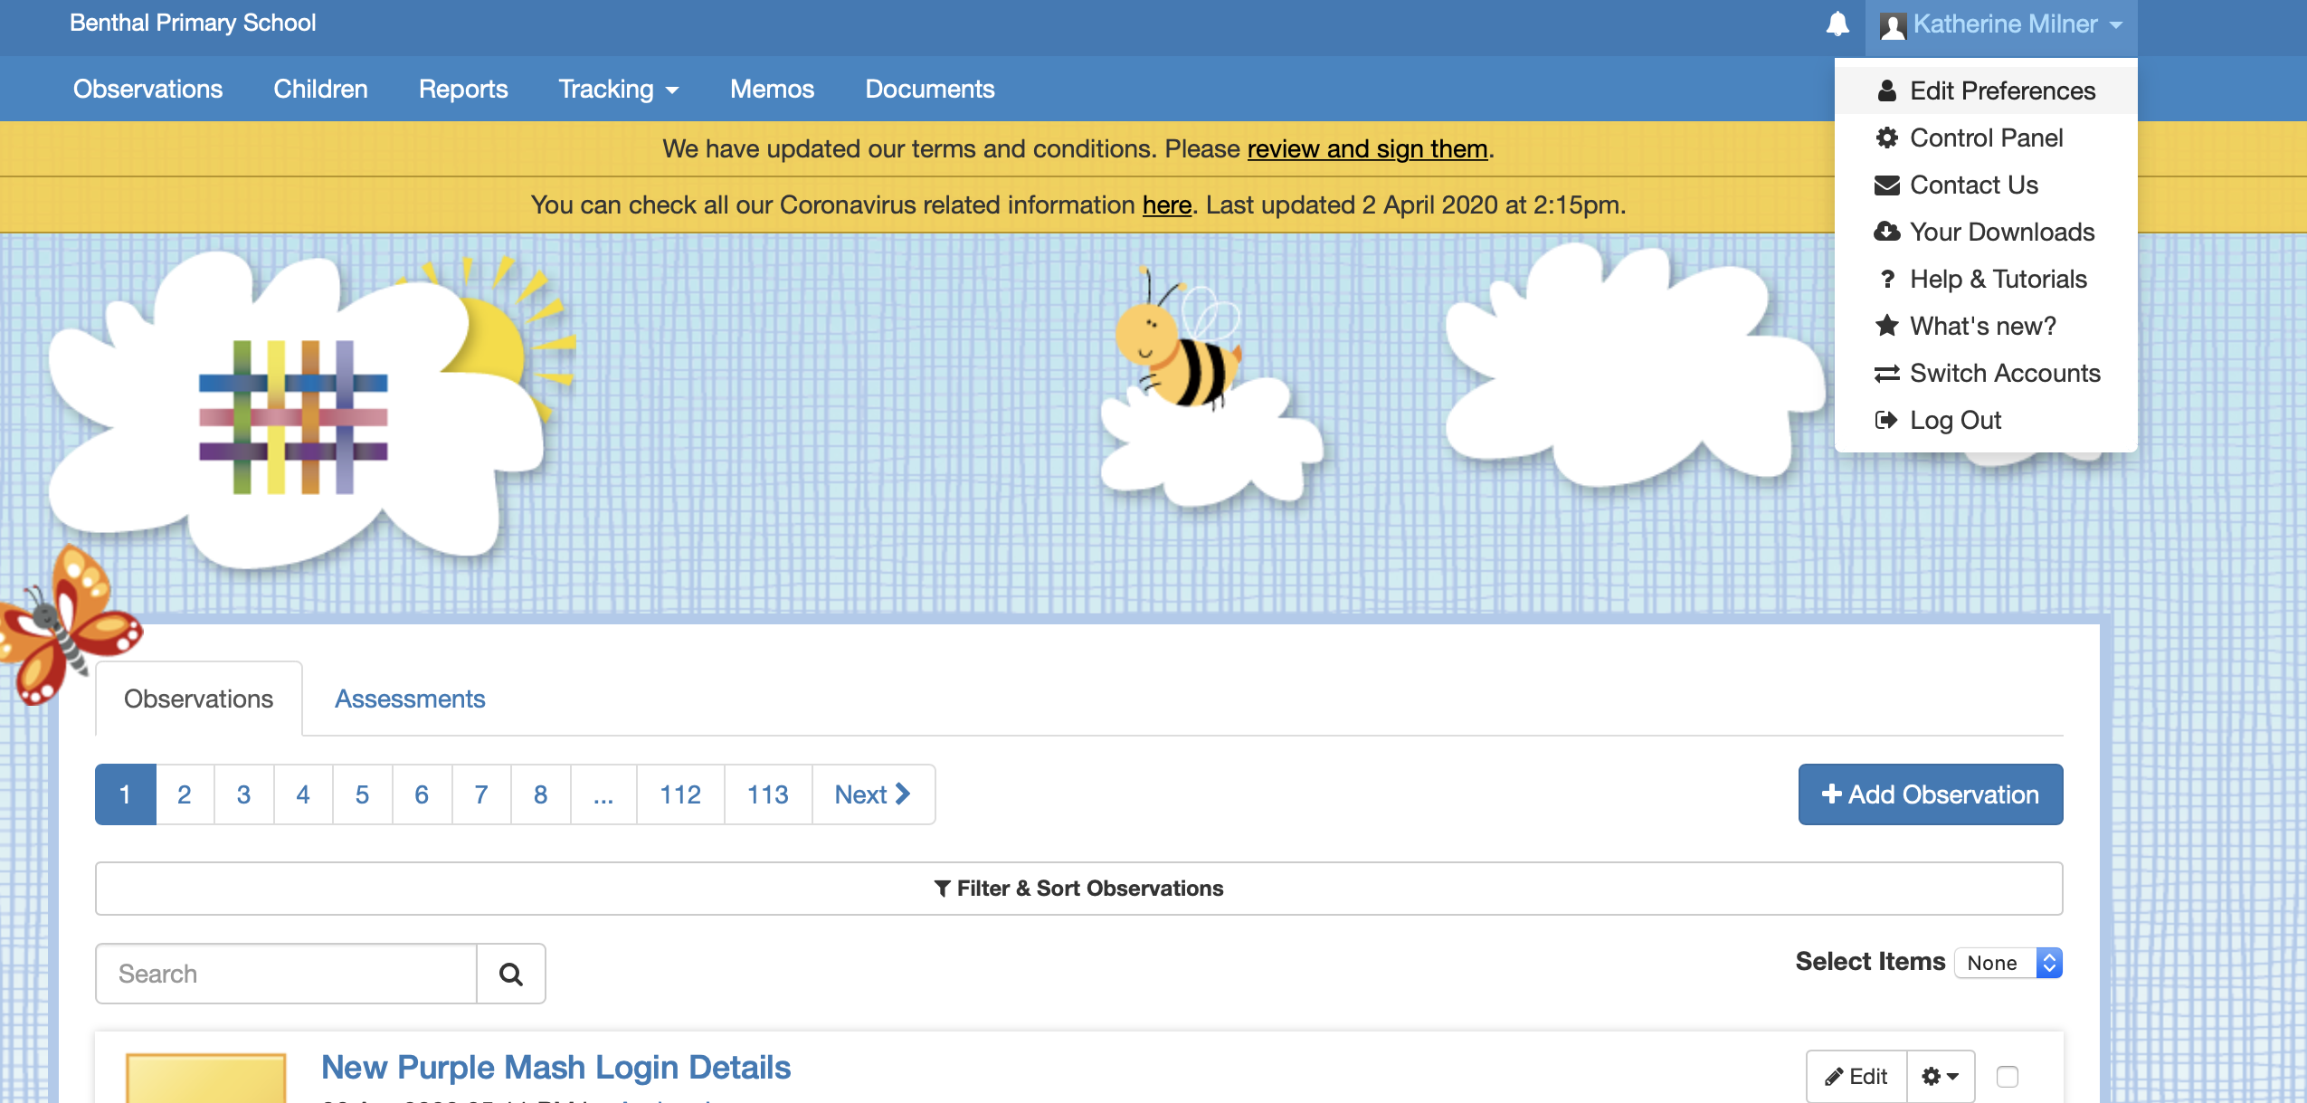
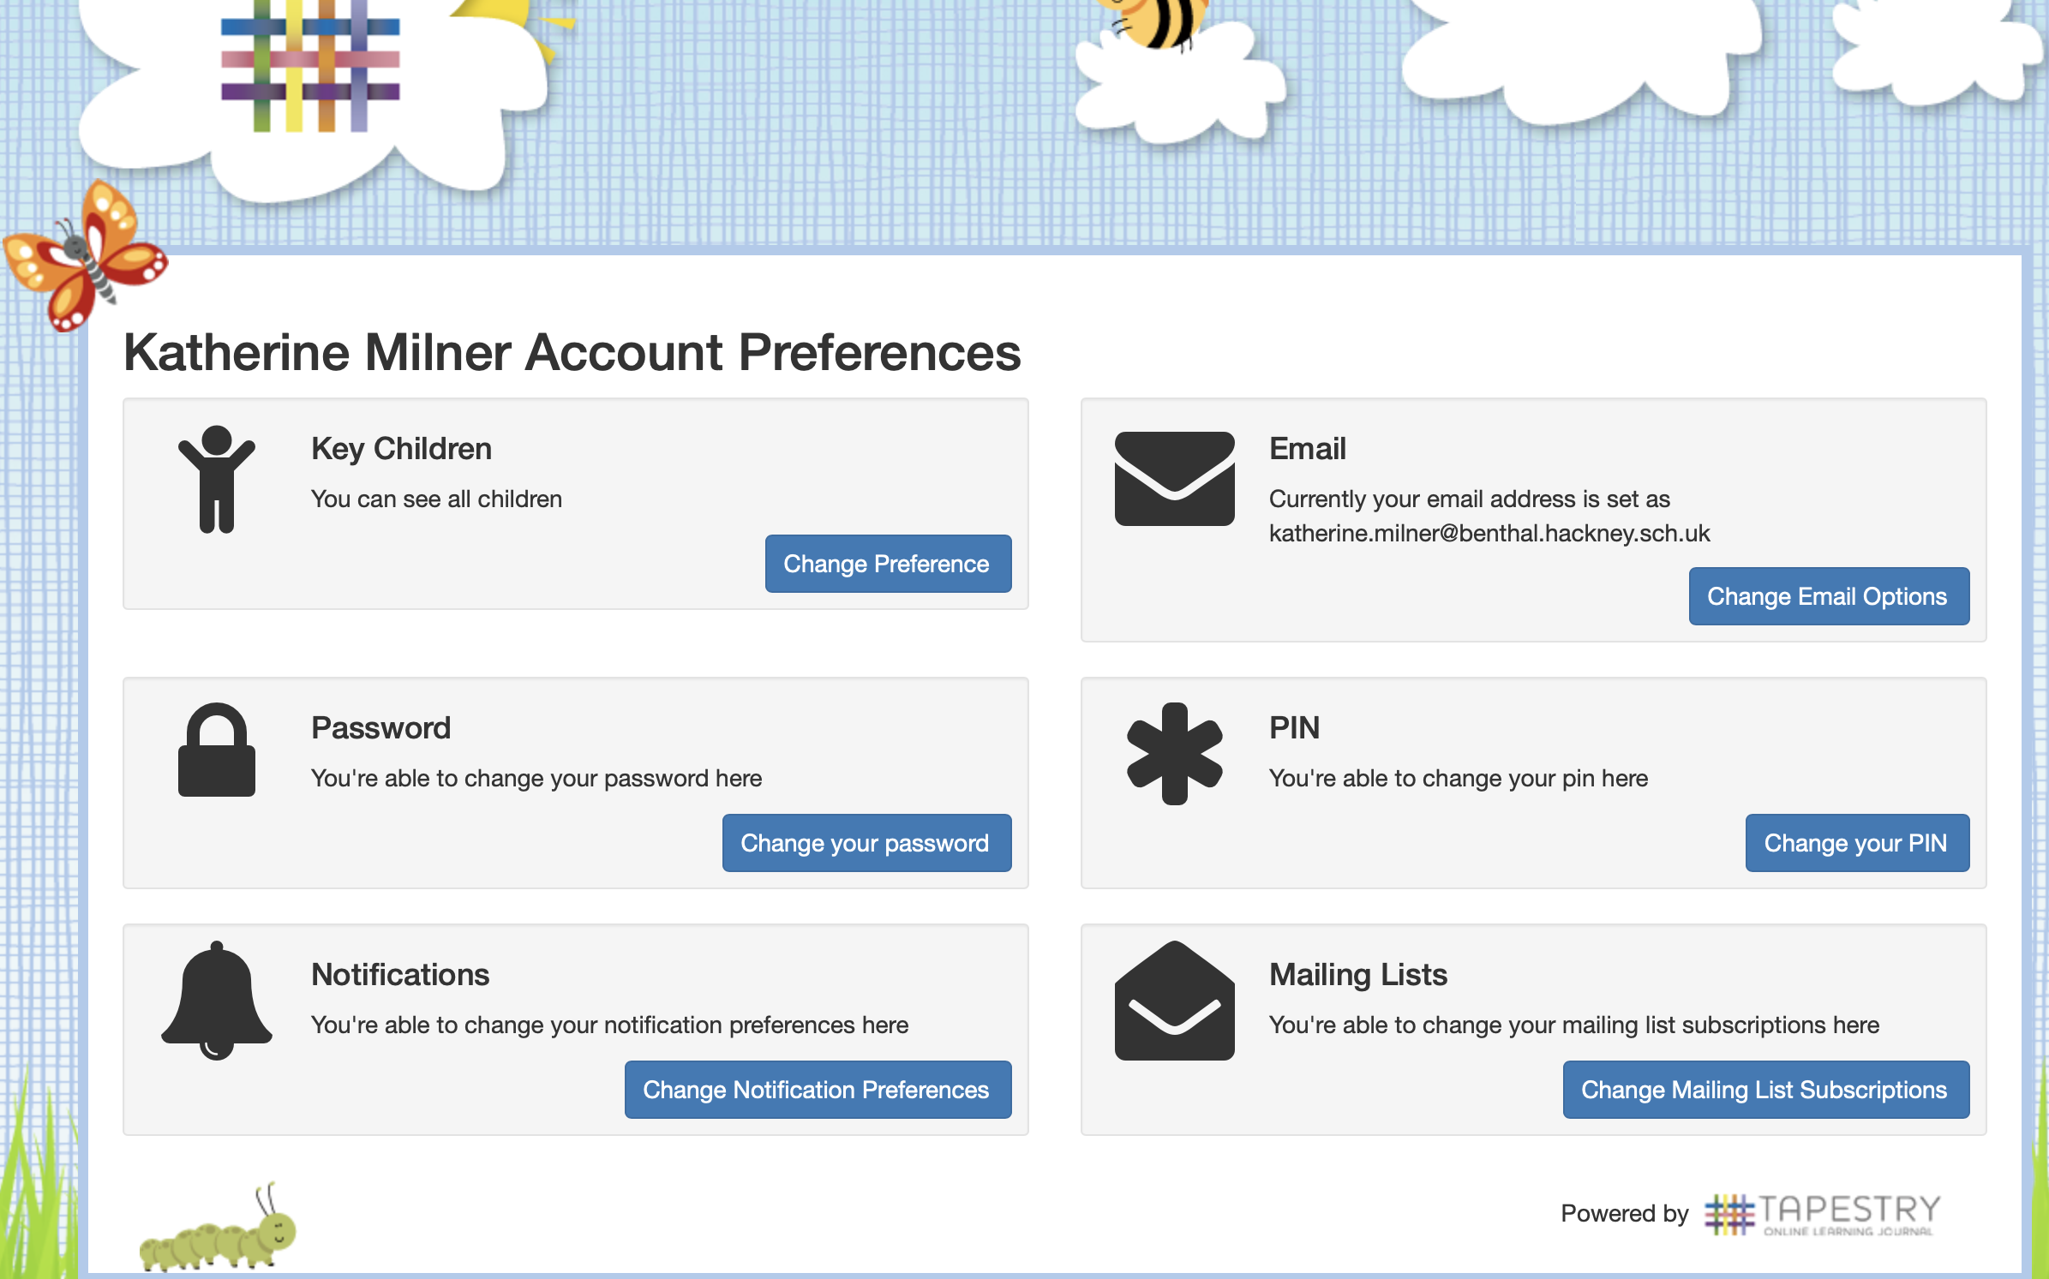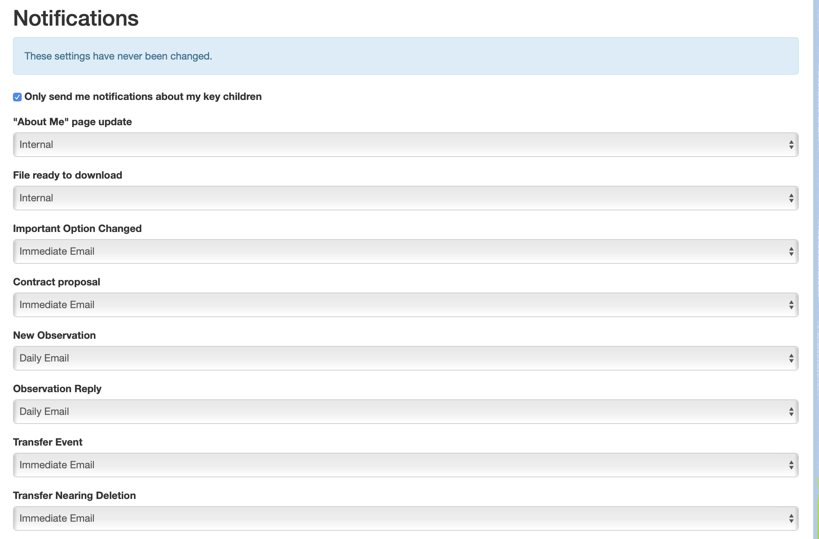
Post Content:
- Tapestry enables families to upload children’s completed work if they wish and to ask you questions about the tasks. Clear guidance will be given to parents/carers stating the purposes of these posts.
- Please use your professional judgement to adopt your usual friendly tone with the messages but try to keep this to statements rather than questions (I hope you’re all well and have been looking after yourselves, take care, any tips for avoiding boredom etc!)
- Tapestry is a tool for staff to communicate with parents and carers. It is of course fine to pass well wishes through the parent to the child. In the unlikely circumstance that you suspect that communications are coming from the child directly, please inform SLT immediately.
- Please do not answer questions from parents/carers that are unrelated to the tasks set, or respond to comments about school ethos and/or policies.
- If any issues arise and you are not sure how to respond, please contact the member of SLT on duty for that day via email, phone or the school office.
Safeguarding:
- Do not download or save any uploaded content from families to any device for example your own mobile phone or school or owned laptop/PC or to the All Staff folders through remote access
- Do not forward or share any uploaded content from families to a third party, even to another member of Benthal school staff.
- If you have a post that you would like to share on the school’s twitter page, first seek permission from the parent/carer. Permission can be sought in the comments section of the relevant post. Then, inform C.Nkaka of the relevant post so that it can be downloaded in a secure way from a school computer then deleted.
- If you have any concerns about a particular child or family following your email contact with them please email myself or Jill and label it ‘Sharing Concerns for a child in X class’- do NOT put the child’s name in the Re: box.
- If it is urgent then call the school office and speak to the SLT member on duty or me on 07780501006 and we can go from there.

These protocols are:
- subject to change as time passes
- sit alongside the clear safeguarding practices that we follow at Benthal
Please be aware that these protocols need to be followed, disciplinary action may be taken if they are not

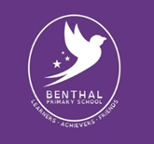
APPENDIX 4

Parent & Carer Guide to Using Class Based Email for
Year 2 and All Junior Children
- Class Emails will be used in the following ways:-
- Class email will be used 9.30am -3.30pm (Monday to Friday, term time only) for helpful curriculum- based communications between teachers and parent/carers and their children as a family

- Teachers may send helpful educational website links or video clips or further Home Learning Tasks or guidance to support parents/carers

- Only parent/carer emails will be used

- Parents/carers can email with questions about the tasks set- teachers will reply within two working days

- Parents/carers can share/upload home learning tasks that their child has completed via email or directly to our Twitter account if they wish

- Class Emails are not for:-
- Teachers to mark any uploaded work/tasks or to give feedback on an individual child’s learning

- Teachers to discipline children if tasks are not completed

- Parents/carers giving feedback or commenting on whole school ethos/policies

- Parents/carers asking questions unrelated to the Home Learning Tasks set

Class emails will be used during school closure and will be reviewed once the pupils return to school
Safeguarding
Keeping everyone safe is our top priority.
During this period of school closure and to ensure the safety of you and your family and Benthal staff all online outputs from the school will strictly adhere to the Benthal Safeguarding Policy and Benthal E-Safety Policy.
Any safeguarding concerns will be reported immediately.

