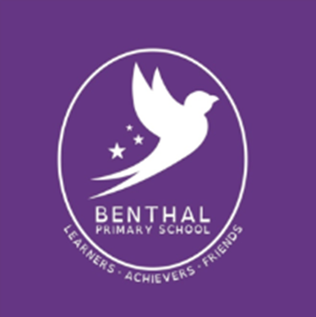

Benthal Primary School

Literacy Policy

Approved by: | Chair of Governors
Approval date: | June 2020
Review date: | May 2022

Literacy Policy

Aims:
1. To produce fluent independent readers who have an understanding of the value of reading both for educational purposes and for pleasure.
2. To produce confident and successful writers who can express ideas clearly and communicate experiences when writing for a range of purposes and audiences.
3. To enable children to be confident and independent users of language within a wide range of learning and social contexts across the whole curriculum also taking into account the importance of spelling, punctuation and grammar.

Role of the Literacy Lead, Management and Training
The Literacy Lead’s main responsibility is to promote the school’s vision and ethos by ensuring that the teaching and learning of literacy are delivered consistently and to a high standard across the school. The Lead will also ensure the use of strategies and approaches to raise standards in Literacy and accelerate the progress rates of all groups and cohorts.
The Literacy Lead will:
- Organise whole school initiatives and events to promote the learning of reading, writing and the development of speaking & listening as a key priority.
- Attend regular forums and training provided by the local authority.
- Work with consultants and agencies to provide relevant learning experiences
- Manage a budget and other resources effectively.
- Provide and/or deliver high quality CPD for all staff across the school, including any 1-2-1 support for colleagues
- Monitor and measure the impact of initiatives and interventions by tracking the progress of all cohorts and adjusting provision through the use of this.
- Use data and formative assessment to measure pupil attainment and progress
- Provide a report to SLT, Local Authority and Governors each term to evaluate the impact of initiatives and the effectiveness of provision.

Teachers have access to training in the teaching of Literacy through:
- Staff meetings - to share expertise.
- Use of specialist teachers for support.
- Visits to other schools.
- Moderation and other courses provided by the borough and HSTA.

Reading
The ability to read independently is essential for children to achieve their potential in all areas of the curriculum. In order to become successful and avid readers children will have the following learning opportunities:
- Daily differentiated phonic lessons in KS1 and Reception
- Additional guided reading sessions for KS1.
- Daily guided reading sessions for KS2.
- Shared reading sessions for all children every day.
- Opportunities to read to an adult individually at various stages of their learning and according to need.
- Access to quality texts either in the library or in classroom libraries.
- Reading books to take home that are at an appropriate level and are regularly assessed to allow them to make progress.
- Opportunities to listen to high quality texts.
- Additional individual reading time to increase stamina.
- Buddy Reading once a week.
- Author focus for each year group each term.
- World Book Day events & Author visits.

Guided Reading
Guided Reading takes place across the school. Each child participates in a planned Guided Reading session with an adult at least once a week. In sessions where they are not reading with an adult, children should have an appropriate reading activity that is planned for and matched to their reading level. All Guided Reading sessions are planned in order to make sure that the main reading strands are covered. These strands consist of word reading, comprehension and being a reader. (See the reading fundamentals in the Assessment policy). Reception children participate in twice-weekly story sessions in small groups. The text is read to them; the purpose of these sessions is to develop comprehension skills. More information can be found in the EYFS Reading policy.

Book Band Levels
Guided Reading books are levelled according to a system used in most UK Primary schools, called ‘book bands’. There are eighteen book bands, and a chart is used to identify which book bands are appropriate for children of different ages, and also how they match the Read Write Inc programme as well as the Oxford Reading Tree, a reading scheme used in many Primary schools.

Key Stage 1 Reading Scheme
The main reading scheme used in KS1 is Read Write Inc (RWI). Children will take an RWI reading book home every week.

Alongside the RWI books there are additional levelled Oxford Reading Tree (ORT) books for children to take home that can be read in conjunction with the appropriate level of RWI books. Children will read these books with an adult at school before it is sent home.
The following sets out the Read Write Inc and broad end of year expectations in Key Stage 1.
End of Reception – Set 1
End of year 1 – Set 2 and 3
End of year 2 – Securing Sets 1- 3

Phonics
An essential requirement for the successful development of reading skills is for children to experience a broad and rich language experience for their earliest years. The provision of this experience is a central feature in our English curriculum in the Early Years Foundation Stage (Nursery and Reception) and Key Stage 1 (Years 1 &2), and supports the acquisition of phonic and word recognition skills. Phonic and word recognition skills continue to be taught in lower Key Stage 2 (Years 3 & 4) in response to the needs of individual children.

Phonic skills are taught using the approach and resources contained within the ‘Read Write Inc.’ (RWI) programme. RWI is a systematic, synthetic phonics programme which teaches children to understand written language and how to decode it. The programme is delivered by teachers and teaching assistants to the whole class or small groups of children. The groups are organised according to ability and the groupings are reassessed half termly. Phonics teaching takes place every day for years R to 2. Phonic catch-up groups are organised across Years 3-6, again these are organised by children’s ability. When pupils complete the programme, they progress to literacy lessons which are taught by the class teacher.

Key Stage 2 Reading Scheme
Key Stage 2 have access to a vast selection of reading books, which are carefully graded by reading levels known as book bands. According to each pupils’ book band, teachers are able to select books with confidence, knowing that they are the right level for each individual child. Each book band has its own colour which is based on the level of reading difficulty.
Alongside the book banding system, KS2 will have a variety of schemes to give a wide range of reading. These include Tree Tops, Rapid Reading books, Oxford Reading Tree and Pocket Readers.
These schemes are all levelled in line with National Curriculum levels and the book banding system. It is the teacher’s responsibility to make sure that children are:
- Reading at the appropriate level.
- Regularly assessed to move up reading stages.
The assessment of reading is done through the school’s assessment system which combines teacher assessment and formal assessment to help inform whether a child is ready to move up a level in reading book bands. There is a clear system which allows teachers to then give a reading level based on the child’s book band level. The assessments themselves, however, do not refer to levels, as the school uses the standard grading system presented by the 2014 government expectations. This evaluates each child as “working below”, “working towards”, “working at expected” or “working at greater depth”, and hence gives a better understanding of the progress of each child.
It is essential that teachers know the level at which children are reading and that they keep a track of their progress through the scheme books.
Home reading is an essential part of the language experience, for both child and the wider family, and parents/carers have a responsibility in supporting their child in this regard. Home reading is monitored by the Teachers or Teaching Assistants. If a child is not completing their home reading, the class teacher will contact the parent to discuss the importance of ensuring that this takes place. If the situation requires, a further meeting may be arranged to explore appropriate support strategies. Furthermore, Champion Reader, a home reading initiative has been set up to encourage home reading and parental involvement. Pupils in KS2 receive a new Champion Reader card every 6 weeks and are encouraged to read at home for at least 10 minutes a day for a minimum of 5 days a week. Parents check and sign the card before the children can receive a raffle ticket. At the end of each half-term a raffle is drawn and a child from each class is awarded with a prize.

Destination Reader
Destination Reader (DR) is an adapted approach to teaching reading in KS2. The approach involves daily sessions incorporating whole class modelling, prior to the children applying these skills through partner work and independent reading. DR is delivered at the start of the day as reading is prioritised to help stimulate children with quality texts, and encourage the development of a variety of skills.

The timetable on page 6 exemplifies the weekly structure of DR and how each session is implemented. Our aim is to promote a purposeful reading provision which allows all pupils to deepen their understanding of the texts they read through the systematic use of a series of strategies and language stems (appropriate sentence starters). The children take part in a vocabulary session once a week to develop their clarifying skills and become familiar with new words.
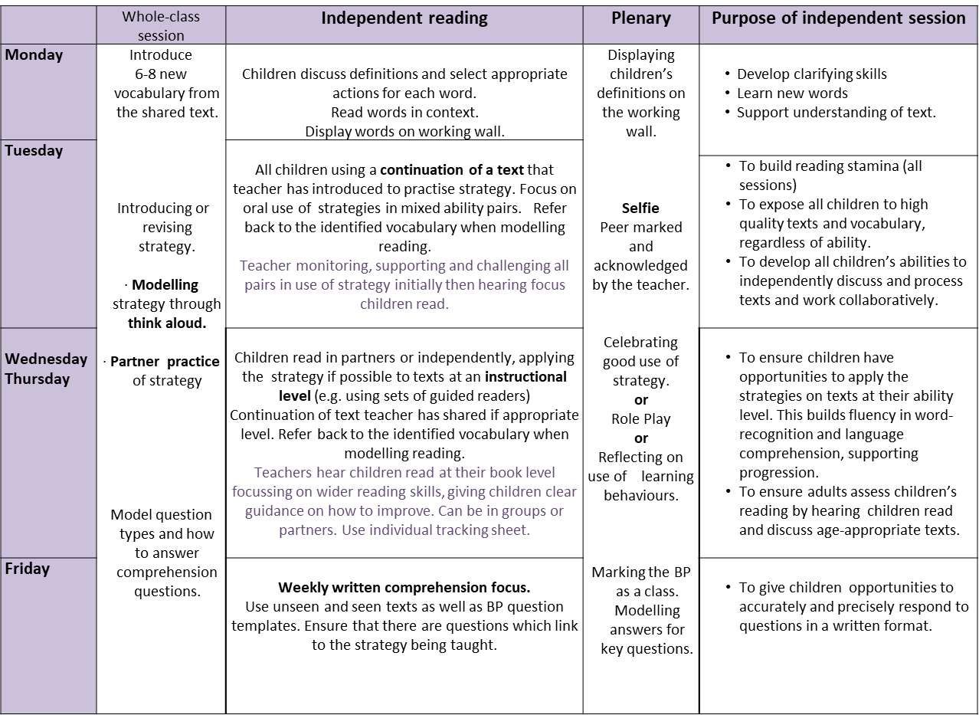
The implementation of DR has been further adapted in year 6 to provide additional support for pupils in preparation for the end of KS2 assessment (SATs). Teachers follow a precise timetable allowing them to enforce quality teaching strategies to deliver effective reading sessions. Some of these strategies include:

• Combining reading strategies and not teaching individual strategies.
• Allowing pupils to build stamina through timed reading sessions.
• Encouraging independent reading more than partner reading.
• Less reliance on using stems.
• Focus on retrieval, clarifying and inference style question types.
• More focus on written comprehension across the week which mirrors the test format.
• Unseen comprehension questions building in length.
• Use of test analysis and ongoing assessment to plan questions.
• Modelling reading, focusing on skimming and scanning and how to answer questions using a variety of tips and techniques.

School Library
Each class has access to the newly renovated Library which they can use for group or whole-class work as well as changing library books. Each class is given a weekly slot where they could visit the library to explore, find, read, borrow and return books. In addition, the library is open every lunchtime for all children and is run by parent volunteers. A Family Library service will be available to all families once all initial plans have been put in place, to support the school’s offer of a rich and varied language experience for the wider school community. In the interim, the library is open to families on Friday mornings but without borrowing books. Additionally, each class has a class library which is topped up regularly.

Speaking and Listening
Speaking and Listening is central to children’s learning experiences in literacy and across the curriculum, and is a priority in the EYFS. Intensive support is given in the early years in order for strong language acquisition to be gained. This support is taught to all and then targeted groups/individuals using National Early Language Initiative (NELI). Listening is utilised to create opportunities for children to rehearse sentences and writing ideas (talk for writing). Teachers aim to create a learning environment where children’s opinions, remarks, and ideas are encouraged and valued. Children will learn that it is important to listen to others and what makes a good listener (talk partners). They are also taught how to speak for a variety of audiences and purposes.

Writing
The act of writing consists of two aspects: composition (getting ideas and selecting words) and transcription (the physical effort of writing, spelling and punctuation). In order for children to develop as writers both of these aspects need to be taken into consideration. To give children the best experience of writing, they will have the following learning opportunities:
- Structured and differentiated literacy lessons that are well planned and build upon children’s prior knowledge.
- Opportunities to take part in Shared and Guided Writing where teachers model the writing process.
- Opportunities to write for a range of audiences linked to creativity topics.
- Extended writing opportunities.
- Opportunities to half termly ‘Free Choice’ writing sessions.
- Spelling, Punctuation and Grammar, taught through literacy lesson starters or through a weekly literacy lesson.
- Opportunities to have their writing celebrated and displayed.
- Ensure children hear and see good examples of grammar through listening to stories and analysing texts and by learning standard English modelled at all times.
- Ensuring that more able pupils are challenged in their writing skills by having access to a wider variety of genre choices.
- Handwriting is modelled and taught consistently.
- Whole school story focus at the start of each term where each year group explores the story and produces work using a specific genre.

Literacy Planning
The literacy curriculum gives children the opportunity to experience writing in fiction, poetry and the six main non-fiction genres (Explanation, Recount, Instructions, Persuasion, Discussion and Report). Each unit of work provides the children with a well-planned structure of lessons that build on each other, resulting in children producing an independent piece of writing. Quality texts and models that engage the children are provided and key skills are taught explicitly throughout the unit of work. Each class has a bank of quality texts that are age-appropriate and can be used for planning literacy units.

Each class in Key Stage 1 and 2 has a timetabled session of literacy teaching every
day. Teachers use the Hamilton Trust Long and Medium Term Plans to choose appropriate genres and objectives for Literacy. Reception and Year 1 follow the RWI ‘Get Writing’ programme as part of their literacy teaching. In addition to RWI, Year 1 have a daily 30-minute Spelling, Punctuation and Grammar lesson.

Get Writing
The ‘Get Writing’ programme consists of daily sessions based around phonics, spelling, punctuation, grammar and structured writing activities. The writing activities build on the reading activities that children have completed, helping them to develop ideas and vocabulary for writing.
Shared and Guided Writing
Shared Writing takes place through literacy lessons and is used to model and demonstrate key literacy skills; Guided Writing is planned into lessons to support children in learning specific writing skills according to their individual needs.

Cross-Curricular Writing
The literacy curriculum has been planned to ensure that topics provide a stimulus for writing and that learning links are made between creativity and literacy. Benthal Primary School is proud to have designed their own ‘Benthal Creative Curriculum’ (BCC) and, through this, many opportunities for cross-curricular writing are created. The children are also given the opportunity to develop their literacy skills in other areas of the curriculum. In science, for example, pupils explore a variety of strategies to develop speaking, listening and writing skills to communicate scientific learning. In maths, through our mastery approach pupils are encouraged to use their language skills to solve reasoning questions and other real-life problems. Developing a secure knowledge of key vocabulary and understanding mathematical language is fully embedded across the school. The school also takes part in Challenge Days and Project Days with Skills Builder which enables pupils to work together and use essential literacy skills in different and exciting ways.

Extended Writing
Children must experience writing for an extended period of time. Therefore, extended writing takes place fortnightly in all Year 2 to Year 6 classes. These sessions are followed up with editing lessons where children are taught specific editing skills and are given the opportunity to go through their own produced piece of work and complete a checklist to show their improvements. In KS2 these writing tasks are recorded in a separate extended writing book as it helps to build a portfolio for each child.

Handwriting
Throughout the Early Years, children have access to a range of activities that develop their gross and fine motor skills. There are opportunities for children to “mark make” with a range of writing implements. A cursive handwriting style is taught across KS1 and KS2 and children will be encouraged to join when they begin to write. For examples of letter formation and the teaching sequence for letters please see the Letter-join scheme. Handwriting practice is done weekly and teachers use their professional judgement to decide how much practice their class needs each week. Children are also given the opportunity to earn a ‘pen licence’. In order to earn the pen licence children need to show that their handwriting has reached a certain level, as decided by the school or the individual teacher. The children with a pen licence can use a pen in class for all writing tasks.

Spelling
Years 2-6 follow the RWI Spelling programme which is a daily 15-minute interactive programme which uses a variety of resources and activities to engage and to enthuse the children in their learning. It helps children to learn spellings with common patterns and uses rules to help them recall spellings as well as teaching exceptions to these rules. Children are assessed twice a week using dictation and other engaging activities to monitor their progress. Alongside this, there is a focus on high-frequency words and topic related vocabulary in addition to word families.

Spelling Punctuation and Grammar (SPaG)
The RWI phonics programme and the RWI spelling programme both cover most of the National Curriculum outcomes for SPaG across the school. As well as this, classes have a weekly, dedicated SPaG lesson to ensure that children receive full coverage of the curriculum.

Displaying Writing
Displaying children’s writing can help to encourage high standards. Children’s good work and efforts are celebrated through display boards, used by all classes to show good pieces of work. All staff follow the Display Policy in relation to creating corridor displays.

Working Walls
A Working Wall is displayed in each classroom from years 1-6. It includes useful references for the children to use when completing independent work. This may include:

- Key vocabulary to use (connectives, adjectives, adverbs etc.)
- Methods for using key skills e.g. showing where speech marks go in a line of dialogue or how to use a subordinate clause in writing.
- Writing frames or aids for supporting the layout of writing.
The Working Wall is a reference and aid memoir to facilitate children’s independence when writing.
In reception, there are ‘Word Walls’ which feature the week’s new vocabulary. This is to support and actively promote children’s vocabulary development; a crucial focus of our Early Years. The vocabulary is specifically chosen in weekly planning sessions and its aim is to stretch and support all learners. Further to this, weekly work completed by the children across all areas of learning is displayed on a ‘Wow Wall’. The purpose of this is to celebrate children’s achievements, build their confidence and inspire others. This is one of the ways we foster a love of learning from the reception year onwards

SEND and Inclusion
Children with SEND have appropriate differentiation that allows them to succeed and make appropriate progress. The class teacher and SEND coordinator are responsible for literacy planning and assessment for all pupils with SEND, although interventions may be delivered by a Teaching Assistant (TA) or a Learning Support Assistant (LSA). The SEND coordinator works closely with Hackney Learning Trust Specialist Teacher and Speech and Language Therapist, to identify literacy targets and resources that may contribute to a pupil’s Individual Education Plan. Pupils who have been identified as having a specific learning difficulty in literacy may receive additional daily 1-1 support using Toe by Toe literacy programme, or a targeted reading, writing or spelling programme. (see separate SEND policy).

Pupil Premium
At Benthal we currently use the additional funding in the following ways to ensure disadvantaged pupils reach their full potential in developing secure literacy skills:
- To provide short-term intervention programmes for underachieving pupils and those with SEND.
- To provide one-to-one tuition for pupils.
- To provide funding for extra-curricular activities.
- To purchase resources to support literacy learning.
- To provide peer coaching and continuous CPD for staff to improve the quality of teaching.
- To ensure that specialist support is used effectively to improve our literacy provision for key groups.
- To ensure that appropriate provision is made for pupils who belong to vulnerable groups, this includes ensuring that the needs of disadvantaged pupils are adequately assessed and addressed.

We monitor and evaluate our Pupil Premium spending, avoid spending it on activities that have little impact on achievement, and spend it in ways known to be most effective.

Equal Opportunities
In the teaching of literacy due regard will be given to the provision of equal opportunities in accordance with the Equalities and Diversity policy. All children will be given the same opportunities to become literate. At Benthal, teachers set high expectations for every pupil. It is essential for teachers to plan challenging work for pupils whose attainment is significantly above the expected standard. They have an even greater obligation to plan lessons for pupils who have low levels of prior attainment or come from disadvantaged backgrounds. Teachers are able to skilfully integrate a range of instructional approaches and resources to meet the diverse learning needs of all pupils. Teachers also acknowledge their pupils’ prior learning, to identify the gaps in their knowledge and help them make connections between new learning and what they already know. Ongoing assessment is used to identify the learning needs of all pupils and this is used vigorously to inform teaching and learning.

Working with Parent/Carers
Support from Parent/Carers is vital for a child’s progress to be sustained. Parent/Carers are expected to support the school’s homework policy and hear their child read every night. To support Parent/Carers we will hold reading, writing and phonic workshops to develop their knowledge and understanding of how they can support their child at home and work in partnership with the school. Alongside this, the Achievement for All initiative supports target pupils and their families with strategies to support reading and writing at home. Parent/carers are also given the opportunity to observe reading, phonics and writing lessons in action across the academic year.

Monitoring and Assessment

- Teachers use on-going assessment to monitor children’s progress. Each child has their own record sheet for Reading and Writing. These are updated regularly and used as an on-going form of assessment for each child. Reading tests and PM Benchmark tests are used to assess children’s reading. Progress across all areas of learning in EYFS is monitored and recorded through Tapestry. These observations are published so that they can be viewed by parents/carers. For more information on assessment procedures please see the separate Assessment policy.

- The literacy subject leader, Head Teacher or Deputy Head Teacher will monitor written work from an average, above average and below average child for each class. Progression, quality of work and differentiation is monitored and feedback given to individual staff. Senior leaders also listen to children read regularly to monitor attainment and progress across the school.

- The literacy subject leader will monitor unit plans for each year group and feedback to individual staff.

- As part of the school’s drive to raise attainment and achievement for all pupils, a range of monitoring processes take place throughout the academic year to ensure children are working at expected levels, are challenged and are making progress.

Monitoring includes:

- Lesson observations
- Pupil and group interviews
- Work samples
- Assessment and data analysis (including APP)
- Pupil Progress meetings
- Planning, moderation and levelling of children’s work.
Updated – May 2020

