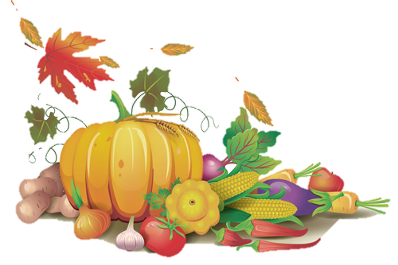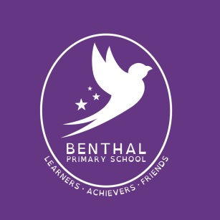

25 September 2020

Dear Parents/Carers,

**Harvest Festival 2020**

Once again as a school we will be celebrating Harvest Festival on **Friday 2nd October.** We will be supporting Hackney Food Bank. It would be lovely if everyone brought in a donation to give to this local charity for local Hackney people and families.

In our assembly we will be teaching our children to think about their lives and the lives of others who have less than themselves.

Please ensure donations are factory sealed, non-perishable and with a good sell by date. Some of the items suggested include:

• Tinned foods: soup, potato, meat/fish, tomatoes, veg, fruit,

• Fruit Juice (carton long life) • Fruit Squash

• Pasta/spaghetti/rice/couscous • Baked beans/cooking sauces

• Rice/sponge pudding [tin] • Tea bags/coffee • Instant Mash • Sugar

• Biscuits/crackers/crispbreads • Healthy Snacks e.g. Raisins/Apricots etc.

We would like the children to bring in a donation by Thursday 1st October and give to their class teacher.

Many thanks,

Ms L Drew

Head Teacher